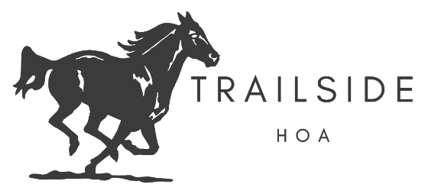
Waiver and information consent to participate in equestrian activities
1890 SW Trailside Path
Stuart, FL 34997
P: 772-408-3000 Fax: 772-325-0535
Website: trailsidehomeowners.com
UNDER FLORIDA LAW, AN EQUINE ACTIVITY SPONSER OR EQUINE PROFESSIONAL IS NOT LIABLE FOR AN INJURY TO OR THE DEATH OF A PARTICIPANT IN EQUINE ACTIVITIES RESULTING FROM THE INHERENT RISK OF EQUINE ACTIVITIES, PER THE SUNSHINE STATE HORSE COUNCIL, INC.
NOTICE OF INHERENT RISKS: : Equines have the propensity to behave in ways that may result in injury, harm or death to persons on or around the equine; have unpredictable reactions to such things as sounds, sudden movement and unfamiliar objects, persons or other animals; are susceptible to certain hazards such as surface or subsurface conditions, collisions with other equines or objects; propensities include kicking, biting, stamping, stumbling, rearing, and others; tack equipment can fail resulting in falling or loss of control; and activities have the potential of a participant to act in a negligent manner that may contribute to injury to the participant or others, such as failing to maintain control over the equine or not acting within the participant’s ability. Equine activities are INHERENTLY DANGEROUS.
I, the undersigned, having read and understood the content of this document, agree and consent to the provisions contained herein. It is my intention and desire to participate in SCA period equestrian-related activities including but not limited to, riding or authorization check rides, horse-handling, ground crew, mounted games and combat, marshalling, or being present at equestrian activities as an observer or other activity related, however slight, to equestrian activities at events held by the Society for Creative Anachronism, Incorporated. I hereby acknowledge that I am fully aware of the nature, purpose and risks of equine activities of the SCA, Inc.. I acknowledge that these activities are potentially dangerous and that I voluntarily accept any of the inherent risks involved. In consideration for my being permitted to take part in these activities, I agree to be bound by the rules of the SCA, Inc. and to obey the directions of the marshals and other governing officials of activities. In the event of any disagreements or disputes arising from my taking part in these activities, I agree to submit such disagreements or disputes to a board of arbitration appointed by the SCA, Inc. and abide by any decisions reached by such board. I agree to release, hold harmless, and keep indemnified the Society of Creative Anachronism, Inc., its organizers and agents, officials, servants, and representatives from and against all claims, actions, costs, expenses and demands in respect to death, injury, loss or damage to my person or property, howsoever caused, arising out of or in connection with my taking part in these events even if the same may have been contributed to or occasioned by the negligence of the said body or any of its agents, servants, or representatives. It is understood and agreed that this agreement is to be binding upon myself, my heirs, executors and assigns.
I UNDERSTAND THAT THIS IS A LEGAL DOCUMENT. I HAVE READ AND UNDERSTOOD THIS RELEASE AND I UNDERSTAND ALL ITS TERMS. I EXECUTE IT VOLUNTARILY AND WITH FULL KNOWLEDGE OF ITS MEANING AND SIGNFICANCE. I HEREBY ASSUME ALL OF THE RISKS ASSOCIATED WITH EQUINE RELATED ACTIVITIES.
Printed name in full: _______________________________________
Signature: _________________________(or parent/legal guardian if under age) Date: ________________
Witness: ____________________________________________ Date: ________________

